Q1. Write a java program to check given character is vowel or not?

Enter Any Character : K

It is not a vowel

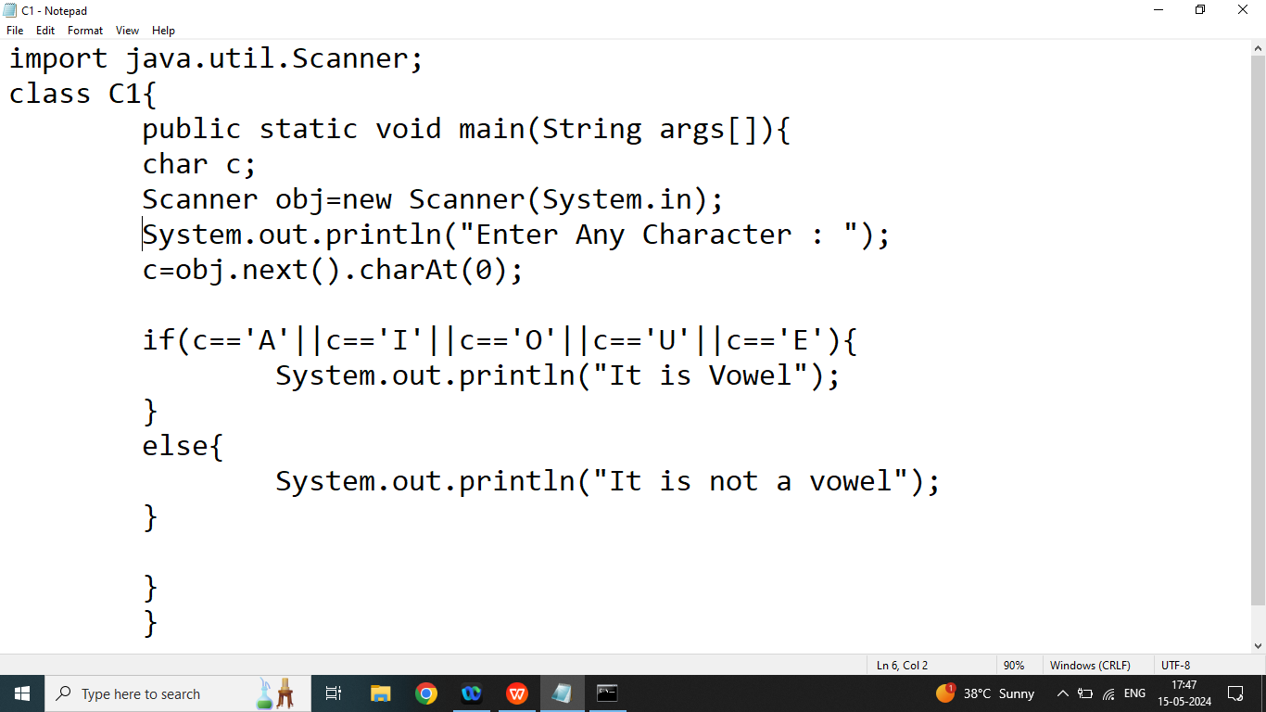

Q2. Explain Nested in in java programming?

Ans:

If we are using if inside another if or else if is also known as nested if.

Syntax:

if(condition1){//97>65

if(condition1_1){

//statement1_1

}

}

else if(condition2){

if(condition2_2){

//statement2_2

}

}

Q3. Write a java program to check given character is Upper Case or Lowercase using nested if.

OR

Write a java program to check given character is Upper case or lower case without using logical operator?

import java.util.Scanner;

//step1:

class C1{

public static void main(String args[]){

char c;

Scanner obj=new Scanner(System.in);

//step2

System.out.println("Enter Any Character : ");

//step3

c=obj.next().charAt(0);

if(c>='a'){//condition1// 97>65

if(c<='z'){//condition1_1

System.out.println("lower Case");

}

}else if(c>='A'){//condition2

if(c<='Z'){//condition2_2

System.out.println("Upper Case");

}

}

}

}

Q3. Explain Switch Statement in java programming?

Ans:

Switch is also used to select one option out of multiple conditions.

Syntax:

switch(constant/variable/Expression/function call){

case constant/expression:

//statement

break;

case constant/expression:

//statement

break;

case constant/expression:

//statement

break;

case constant/expression:

//statement

break;

default:

//statement

}

Note : In switch we cannot define duplicate case

Q2. Write a java program to check given character is vowel or not without using logical and relational operators

OR

Write a java program to check given character is vowel or not using switch.

import java.util.Scanner;

//step1:

class C1{

public static void main(String args[]){

char c;

Scanner obj=new Scanner(System.in);

//step2

System.out.println("Enter Any Character : ");

//step3

c=obj.next().charAt(0);

switch(c){

case 'a' :

case 'A':

System.out.println("It is vowel");

break;

case 'e' :

case 'E':

System.out.println("It is vowel");

break;

case 'i' :

case 'I':

System.out.println("It is vowel");

break;

case 'o' :

case 'O' :

System.out.println("It is vowel");

break;

case 'u' :

case 'U':

System.out.println("It is vowel");

break;

default:

System.out.println("it is not a vowel");

}

}

}

Homework

Q1. Write a java program to create basic calculator using switch or else if?

